TASCO DEPOTS

ALBURY
202 North Street
Albury NSW 2640
P 02 6042 0300
BENDIGO
45 Sandhurst Road
Bendigo VIC 3550
P 03 5446 3133
BENALLA
34 Sydney Road
Benalla VIC 3672
P 03 5761 3400
BROKEN HILL
5 Kanandah Road Broken Hill NSW 2880 P 08 8088 1011
BUNNALOO
RMB 520
Bunnaloo NSW 2731
P 03 5489 7241
COOTAMUNDRA
30 Hovell Street
Cootamundra NSW 2590
P 04 0963 0028
LEETON
9-11 Brady Way
Leeton NSW 2705
P 04 0963 0028
MILDURA
220 Tenth Street
Mildura VIC 3500
P 03 5022 1711
NARACOORTE
237 Smith Street
Naracoorte SA 5271
P 08 8762 1422

ROBINVALE
Moore Street Robinvale VIC 3549
P 03 5026 3539
RENMARK
52 Twenty First Street Renmark SA 5341
P 08 8586 5966
SHEPPARTON
17-26 McGill Street
Shepparton VIC 3630
P 03 5821 5460
SWAN HILL
6-8 Jennings Road Swan Hill VIC 3585 P 03 5032 4469
62 Curlewis Street Swan Hill VIC 3585 P 03 5032 9144
MURRAY BRIDGE
112-114 Swanport Road Murray Bridge SA 5253 P 08 8532 2134
BORDERTOWN
PO Box 117
Bordertown SA 5268
P 08 8752 2555
WODONGA
107 Bradford Street
Wodonga VIC 3690
P 02 6024 2488
WAGGA WAGGA
18 Lewington Street
Bomen NSW 2650
P 02 6921 4710

LOCATIONS GUIDE

PART OF YOUR COMMUNITY

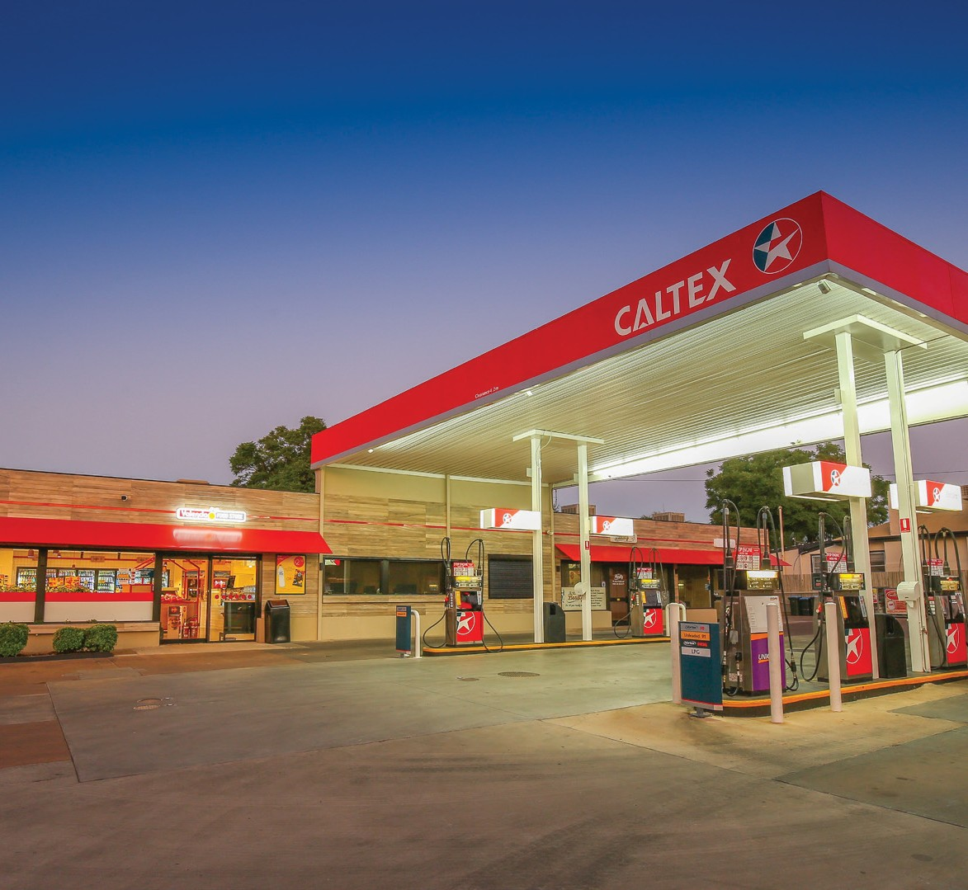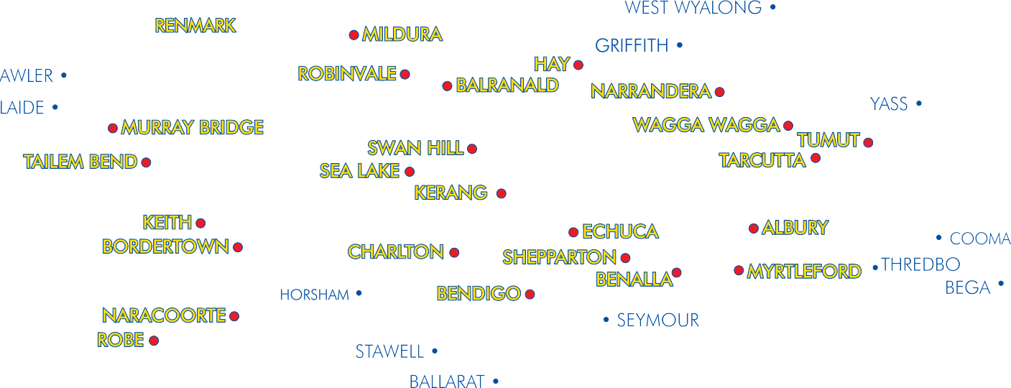FREE CALL 1800 842 842 tascopetroleum.com.au

SERVICE STATIONS WITHIN THE TASCO AREA

TASCO OWNED SERVICE STATIONS
Site Name  Albury | Address/City P/Code  127 North Street  Albury 2640 | Phone  02 6041 3404 | ULP | PULP | PULP 98 | LPG | DIESEL | VORT DSL | 24HR | AD BLUE
 |  |  | ★ |  | ★ | ★ | ★ |  | ★
Balranald | 99 Market Street  Balranald 3672 | 03 5020 1603 | ★ |  | ★ | ★ | ★
Benalla Midlands | 191 Bridge Street  Benalla 3672 | 03 5762 5881 | ★ | ★ | ★ | ★ | ★
Bendigo | 68 Carpenter Street  Bendigo 3550 | 03 5443 2338 | ★ |  | ★ | ★ |  | ★
Bendigo | 93-97 Mcivor Road  Bendigo 3550 | 03 5441 1156 | ★ | ★ | ★ | ★ | ★
Bendigo | 53 Sandhurst Road  Bendigo 3550 | 03 5020 1603 | ★ |  | ★ | ★ | ★
Bordertown | 23 Dukes Highway  Bordertown SA 5268 | 08 8752 2555 | ★ | ★ |  | ★ | ★
Broken Hill Opt | 5 Kanandah Road  Broken Hill 2880 | 08 8088 1011 |  |  |  |  | ★ |  |  | ★
Broken Hill South | 84 Patton Street  Broken Hill 2880 | 08 8087 3653 | ★ |  | ★ | ★ | ★
Charlton Roadhouse | 166-186 High Street  Charlton 3525 | 03 5491 1310 | ★ | ★ | ★ | ★ | ★
Cobram | 88-94 Station Street  Cobram 3644 | 03 5871 1423 | ★ | ★ | ★ | ★ | ★
Cootamundra | 30 Hovell Street  Cootamundra 2590 | 02 6971 0395 | ★ | ★ | ★ | ★ | ★ |  | ★
Corowa Opt | 161 Cemetery Road  Corowa 2646 |  |  |  |  |  | ★ |  | ★
Echuca Roadhouse | 4 Northern Highway  Echuca 3564 | 03 5482 1541 | ★ | ★ | ★ | ★ | ★ |  | ★
Hay Roadhouse | Lot 5 Moama Street - (Sturt Hwy) Hay 2711 | 02 6993 1544 | ★ | ★ |  | ★ | ★ |  |  | ★
Holbrook | 130 Albury Street  Holbrook 2644 | 02 6036 2577 | ★ |  | ★ | ★ | ★ | ★
Kerang | 80 Bendigo Road  Kerang 3579 | 03 5450 3066 | ★ | ★ | ★ | ★ | ★
Leeton | 1 Pine Avenue  Leeton 2705 | 02 6953 5236 | ★ | ★ | ★ | ★ | ★ | ★
Leeton | 44-66 Vance Road  Leeton 2705 | 04 0963 0028 |  |  |  |  | ★ |  | ★
Mildura | 216 Deakin Avenue  Mildura 3500 | 03 5023 3383 | ★ |  | ★ | ★ |  | ★
Mildura Bridge | 90 Seventh Street  Mildura 3500 | 03 5023 8086 | ★ |  | ★ | ★ | ★

Site Name Address/City P/Code Phone |  |  | ULP | PULP | PULP 98 | LPG | DIESEL | VORT DSL | 24HR | AD BLUE
Mildura Walnut Convenience | Cnr Walnut & 15th Streets (1500 Walnut) Mildura 3500 | 03 5021 1734 | ★ |  | ★ | ★ |  | ★
Mildura Westside Valencia | 242 Tenth Street  Mildura 3500 | 03 5023 2827 | ★ | ★ |  | ★ | ★
Mildura Star Mart | 787-793 Fifteenth Street  Mildura 3500 | 03 5022 1941 | ★ | ★ | ★ | ★ |  | ★ | ★
Murray Bridge | 114 Swanport Road Murray Bridge SA 5253 | 08 8532 2134 | ★ | ★ |  | ★ | ★
Myrtleford | 158 Myrtle Street  Myrtleford 3737 | 03 5752 1220 | ★ |  | ★ | ★ | ★
Naracoorte | 46 Gordon Street  Naracoorte SA 5271 | 08 8762 2266 | ★ | ★ |  | ★ | ★
Narrandera Roadhouse | 16321 Newell Highway  Gillenbah 2700 | 02 6959 1812 | ★ | ★ | ★ | ★ | ★ | ★ | ★ | ★
Numurkah | 2 Tocumwal Road  Numurkah 3636 | 03 5862 1481 | ★ |  | ★ | ★ | ★
Ouyen Roadhouse | 15 Farrell Street  Ouyen 3490 | 03 5092 1340 | ★ |  | ★ | ★ | ★
Pyramid Hill | 42 Victoria Street Pyramid Hill VIC 3575 | 03 5455 7214 | ★ |  |  |  | ★ |  | ★
Red Cliffs | 47 Jacaranda Street  Red Cliffs 3496 | 03 5024 1071 | ★ |  | ★ | ★ | ★
Renmark | 52 Twenty First Street Renmark SA 5341 | 08 8586 5966 |  |  |  |  | ★ |  | ★
Robinvale | 70 Bromley Road  Robinvale 3549 | 03 5026 3539 | ★ | ★ | ★ | ★ | ★
Sea Lake | 155 Horace Street  Sea Lake 3533 | 03 5070 1406 | ★ |  | ★ | ★ | ★
Serpentine Roadhouse | Loddon Vally Highway Serpentine 3517 | 03 5437 8385 | ★ |  | ★ | ★ | ★
Shepparton | 103-107 Archer Street  Shepparton 3630 | 03 5821 6712 | ★ |  | ★ | ★ | ★
Shepparton | 187 Wyndham Street  Shepparton 3630 | 03 5822 1166 | ★ | ★ | ★ | ★ | ★ | ★ | ★
St Arnaud | 5948 Sunraysia Highway  St Arnaud 3478 | 03 5495 2209 | ★ |  | ★ | ★ | ★
Swan Hill | 1 Beveridge Street  Swan Hill 3585 | 03 5032 9327 | ★ |  | ★ | ★ | ★
Swan Hill | 62 Curlewis Street Swan Hill VIC 358 | 03 5032 9144 | ★ |  | ★ | ★ | ★
Swan Hill Depot | 6-8 Jennings Road  Swan Hill 3585 | 03 5032 4469 |  |  |  |  | ★ |  | ★ | ★

Site Name Address/City P/Code Phone |  |  | ULP | PULP | PULP 98 | LPG | DIESEL | VORT DSL | 24HR | AD BLUE
Tarcutta Roadhouse | Lot A Sydney Street Tarcutta 2652 | 02 6928 7177 | ★ | ★ | ★ | ★ | ★ | ★ | ★
Tumut | 42-44 Adelong Road  Tumut 2720 | 02 6947 6611 | ★ |  | ★ | ★ | ★
Tailem Bend | 160 Princess Highway Tailem Bend SA 5260 | 08 8572 3976 | ★ | ★ |  | ★ | ★ |  | ★ | ★
Wagga Wagga | 131A Fernleigh Road Wagga Wagga 2650 | 02 6931 4322 | ★ | ★ |  | ★ |  | ★
Wagga Wagga | 7 Lake Albert Road Wagga Wagga 2650 | 02 6921 6968 | ★ |  | ★ | ★ |  | ★
Wagga Wagga | Edwards St & Station Pl Wagga Wagga 2650 | 02 6921 1544 | ★ | ★ | ★ | ★ |  | ★
Wagga Wagga Roadhouse | 151 Hammond Avenue  Wagga Wagga 2650 | 02 6921 5309 | ★ |  | ★ | ★ | ★ | ★ |  | ★
Wedderburn | 117 High Street  Wedderburn 3518 | 03 5494 3079 | ★ |  | ★ | ★ | ★
Wentworth | 17 Sandwych Street  Wentworth 2648 | 03 5027 2257 | ★ |  | ★ | ★ | ★
Wodonga | 107 Bradford Street  Wodonga 3690 | 02 6024 2488 |  |  |  |  | ★ | ★ | ★
Wodonga Gateway | High Street & Thomas Mitchell Drive 3690 | 02 6056 6701 | ★ |  | ★ |  |  | ★
Wodonga Roadhouse | 178 Melbourne Road  Wodonga 3690 | 02 6024 1983 | ★ | ★ | ★ | ★ | ★ | ★ | ★ | ★

TASCO SUPPLIED SERVICE STATIONS
Site Name | Address/City P/Code | Phone | ULP | PULP | PULP 98 | LPG | DIESEL | VORT DSL | 24HR | AD BLUE
Albury | 609 Hovell Street Wodonga Place Albury 2640 | 02 6021 4011 | ★ | ★ |  | ★ | ★
Berrigan | 162 Jerilderie Street  Berrigan 2712 | 03 5885 2153 | ★ | ★ |  |  | ★
Broken Hill Lindsays | 1 Blende Street  Broken Hill 2880 | 08 8088 2192 | ★ | ★ |  | ★ | ★
Broken Hill (Hillside) | 75 Gypsum Street  Broken Hill 2880 | 08 8087 4527 | ★ |  |  |  | ★
Cohuna | 183 Murray Valley Highway (King George) Cohuna 3568 | 03 5456 2650 | ★ |  | ★ | ★ | ★ | ★
Coolamon | 82 Cowabbie Street  Coolamon NSW 2701 | 02 6927 3024 | ★ | ★ |  |  | ★

Site Name Address/City P/Code Phone |  |  | ULP | PULP | PULP 98 | LPG | DIESEL | VORT DSL | 24HR | AD BLUE
Culcairn | 35 Balfour Street  Culcairn 2660 | 02 6029 8279
Dareton | 1-3 Tapio Street  Dareton 2717 | 03 5027 4505 | ★ |  | ★ | ★ | ★ | ★
Everton | 2128 Great Alpine Road Everton 3678 | 03 5727 0282 | ★ |  | ★ | ★
Keith | Cnr Dukes Road& Riddoch Highway Keith SA 5267 | 08 8755 1700 | ★ | ★ |  | ★ | ★
Loxton | 20 Bookpurnong  Terrace Loxton 5333 | 08 5884 7277 | ★ | ★ |  |  | ★
Manangatang | 9 Wattle Street  Manangatang 3546 | 03 5035 1421 | ★ |  |  |  | ★
Menindee | Perry Street Menindee | 08 8091 4297 | ★ | ★ |  | ★ | ★
Mt Beauty | 1 Lakeside Avenue  Mt Beauty 3699 | 03 5754 4061 | ★ | ★ | ★ | ★ | ★
Rutherglen | 17 Fortune Street  Rutherglen 3685 | 02 6032 8562 | ★ | ★
Tatura | 188-190 Hogan Road  Tatura 3616 | 03 5824 1945 | ★ |  | ★ | ★ | ★
Tibooburra | 1 Silver City Highway Tibooburra 2880 | 08 8091 3477 | ★ |  |  |  | ★
Tumbarumba | 76 The Parade  Tumbarumba 2653 | 02 6948 2523 | ★ | ★ |  | ★ | ★
Walbundire | Billabong Street Walbundrie 2642 | 02 6029 9003 | ★ |  |  |  | ★
Warracknabeal | Cnr Scott & Lyle Streets Warracknabeal 3393 | 03 5394 1868 | ★ |  | ★ | ★ |  | ★
Whitfield | 4885 Main Street  Whitfield 3733 | 03 5729 3677 | ★ |  |  |  | ★
Wilcannia Roadhouse | Barrier Highway Wilcannia 2836 | 08 8091 5957 | ★ | ★ |  | ★ | ★
ENQUIRE ABOUT OUR TASCOPLUS STARCARDS!

NO Fee’s
- Use at any Caltex Australia Wide
- Useful for businesses & large companies

